# **SLTC re:Start Bootcamp**

# **Final Assignment (Group project)**

# Project name: Library Management system for a small school

# Team members:

|  |  |
| --- | --- |
| **Student ID** | **Full Name** |
| RS19113 | M S M Shazir |
| RS19123 | W Iresha U Silva |
| RS19122 | F.M. N Aysha |

# GitHub URL: <https://github.com/BootcampProgram/NewLibraryManagementSystem>

# Demo URL (if available):

Contents

**SLTC re:Start Bootcamp** 1

**Final Assignment (Group project)** 1

Project name: Library Management system for a small school 1

Team members: 1

GitHub URL: https://github.com/BootcampProgram/NewLibraryManagementSystem 1

Demo URL (if available): 1

Technical documentation 3

Introduction 3

Use case diagram 4

Navigation map 5

Sample UI 7

Database relationship (ER) diagram 15

Business logic 15

Final screenshots 16

# Technical documentation

## Introduction

The project Library Management System aims at developing a fully functional computerized system to maintain all the day to day activity of a library. The main aim of this project is providing an easy to handle and automated Library Management System. Manual Library Management System involves lots of paperwork as the Library information including user data, librarian data, book records, among others are all documented manually. Also issuing and returning books are done manually leading to waste of time and resources from the users and library authority.

This project has many features which are generally not available in normal Library Management Systems like facility of user login and facility of librarian login. It also has a facility of admin login through which the admin can monitor the whole system. Books and students maintenance modules are also included in this system which would keep track of the students using the library and also a detailed description about the books a library contains. With this computerized system there will be no loss of book record or member record which generally happens when a non-computerized system is used.

This project also provides features and interfaces for maintaining librarian’s record, student’s record, student’s history of issue and return, reservations etc. The librarian can create, view, update and delete book details. And also he can issue the books to the students and maintain their records. It shows trending book among the students too. Searching, adding and modifying information has been made easy, so the librarian doesn’t have to be an expert in Library administration.

In this project we can maintain the late fine of students who returns the issued books after the due date. This system allows the students to view the book details, reserve books, and add books to wish list. The goal of this project is to provide simplicity as well as security and efficiency to the management. This system has user friendly interface, fast access to database, less errors, more storage capacity, search facilities as advantages.

Overall this project is being developed to help the students as well as staff of library to maintain the library in a best way and to reduce the human effort.

## Use case diagram

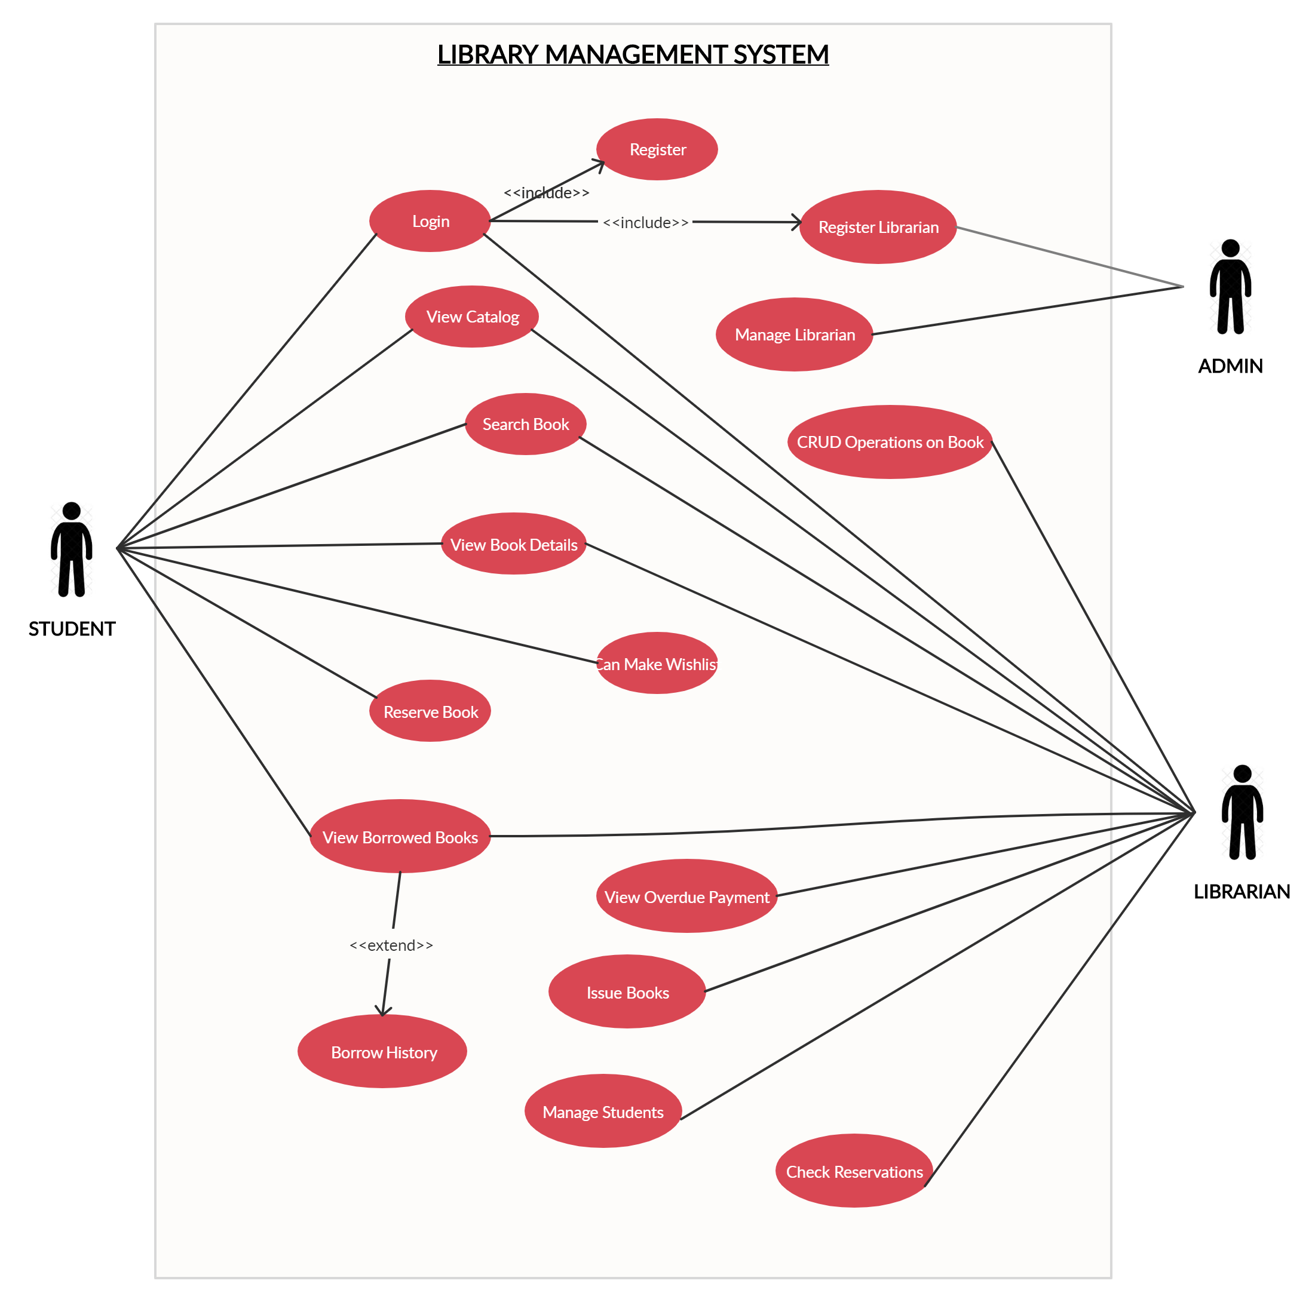

Figure : Use case diagram

## Navigation map

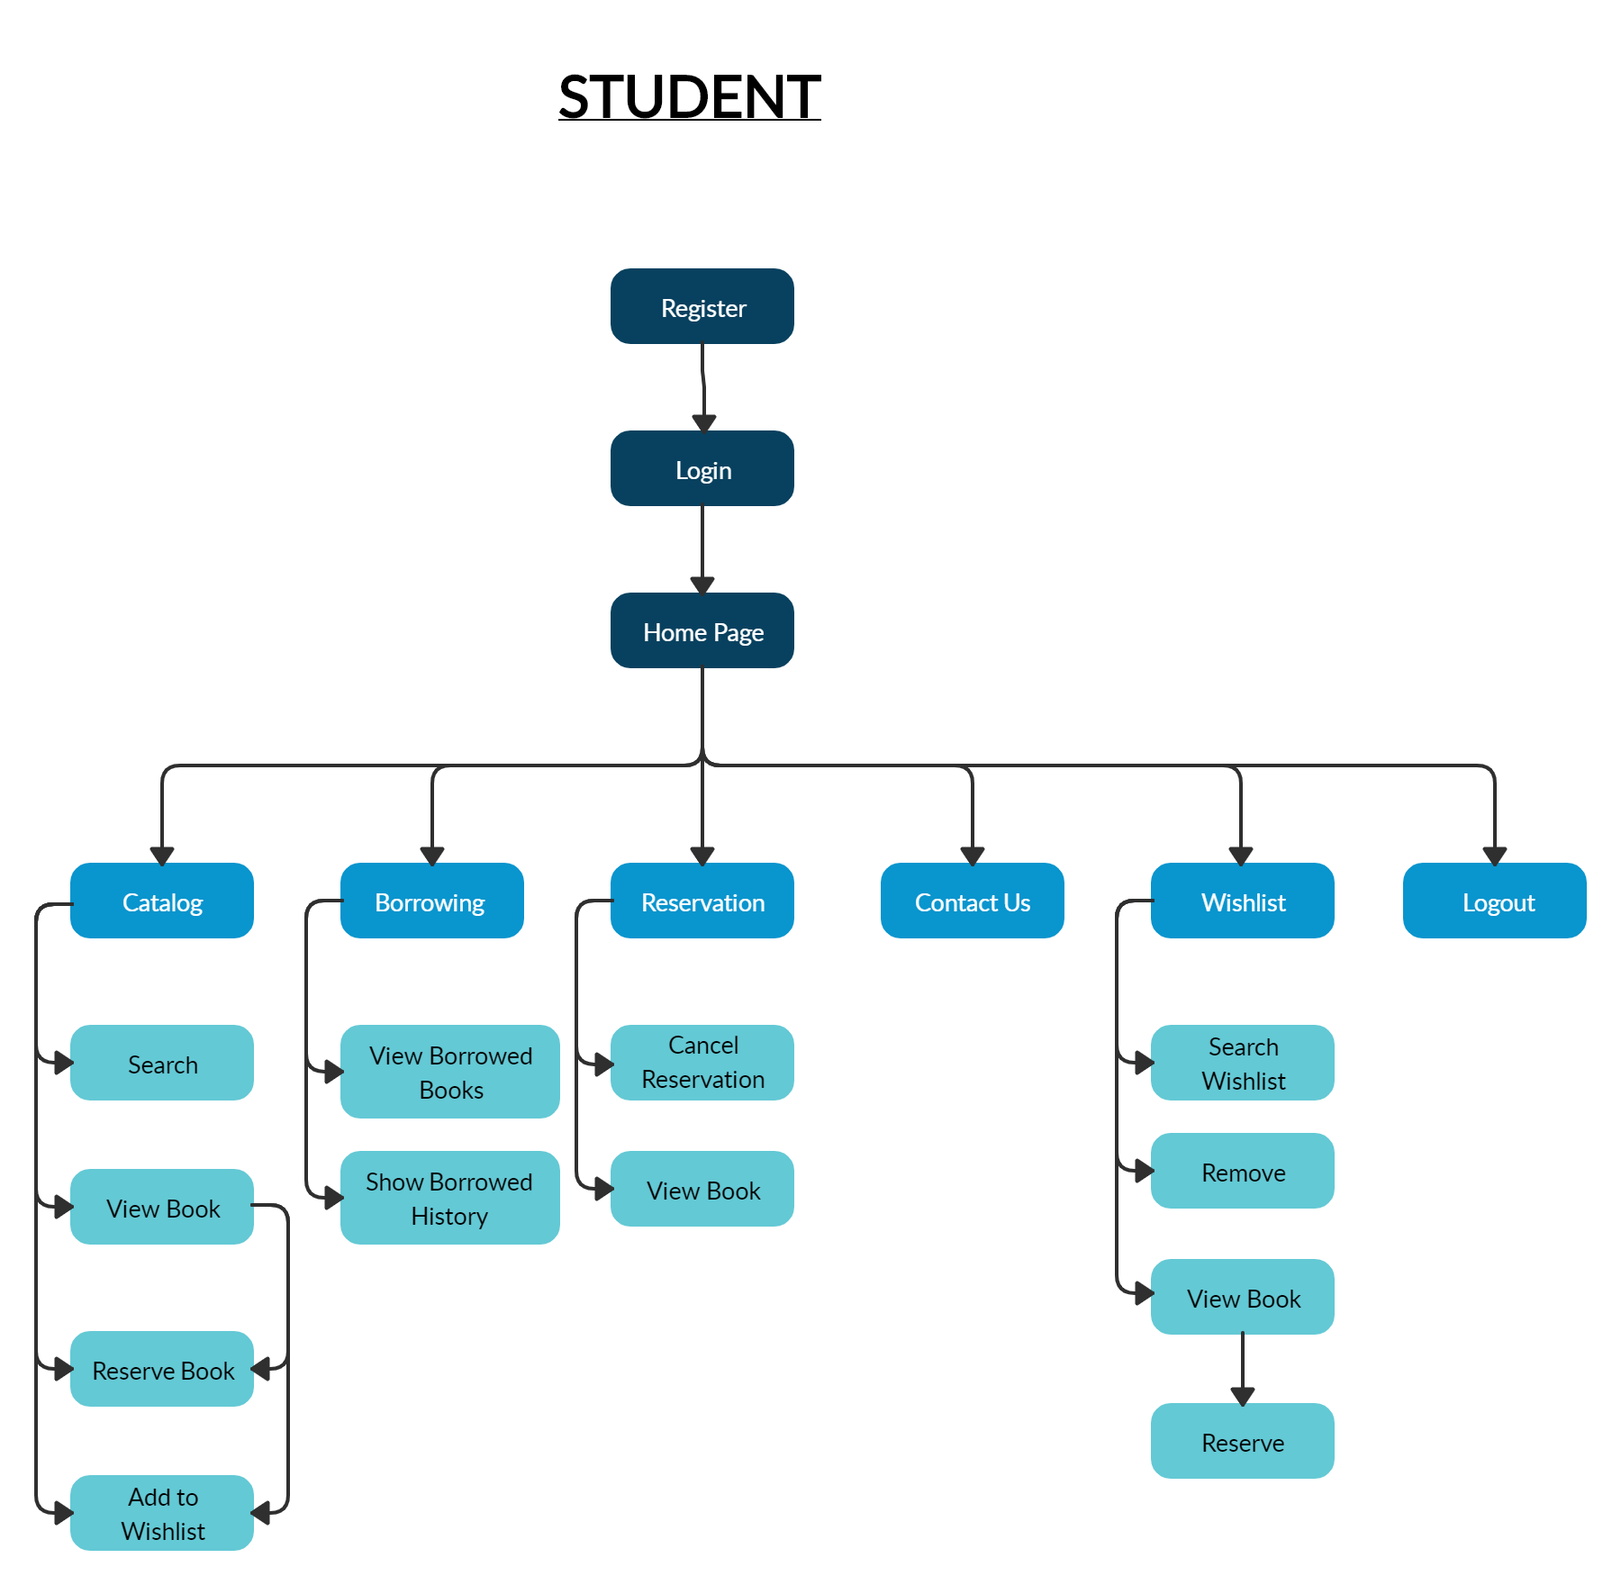

Figure : Navigation map of a student

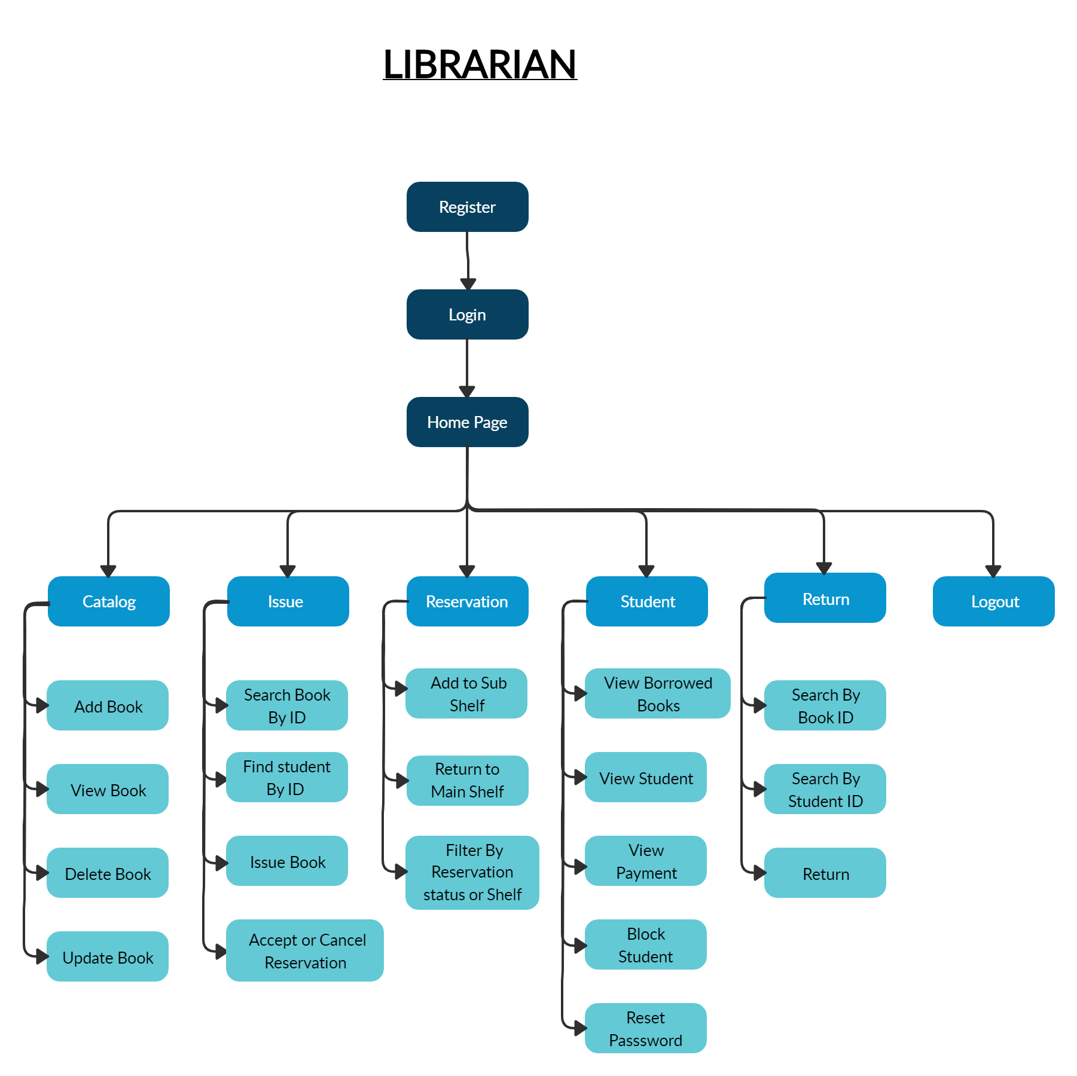

Figure : Navigation map of a librarian

## Sample UI

**Student’s Sample UI**



Figure : Login page

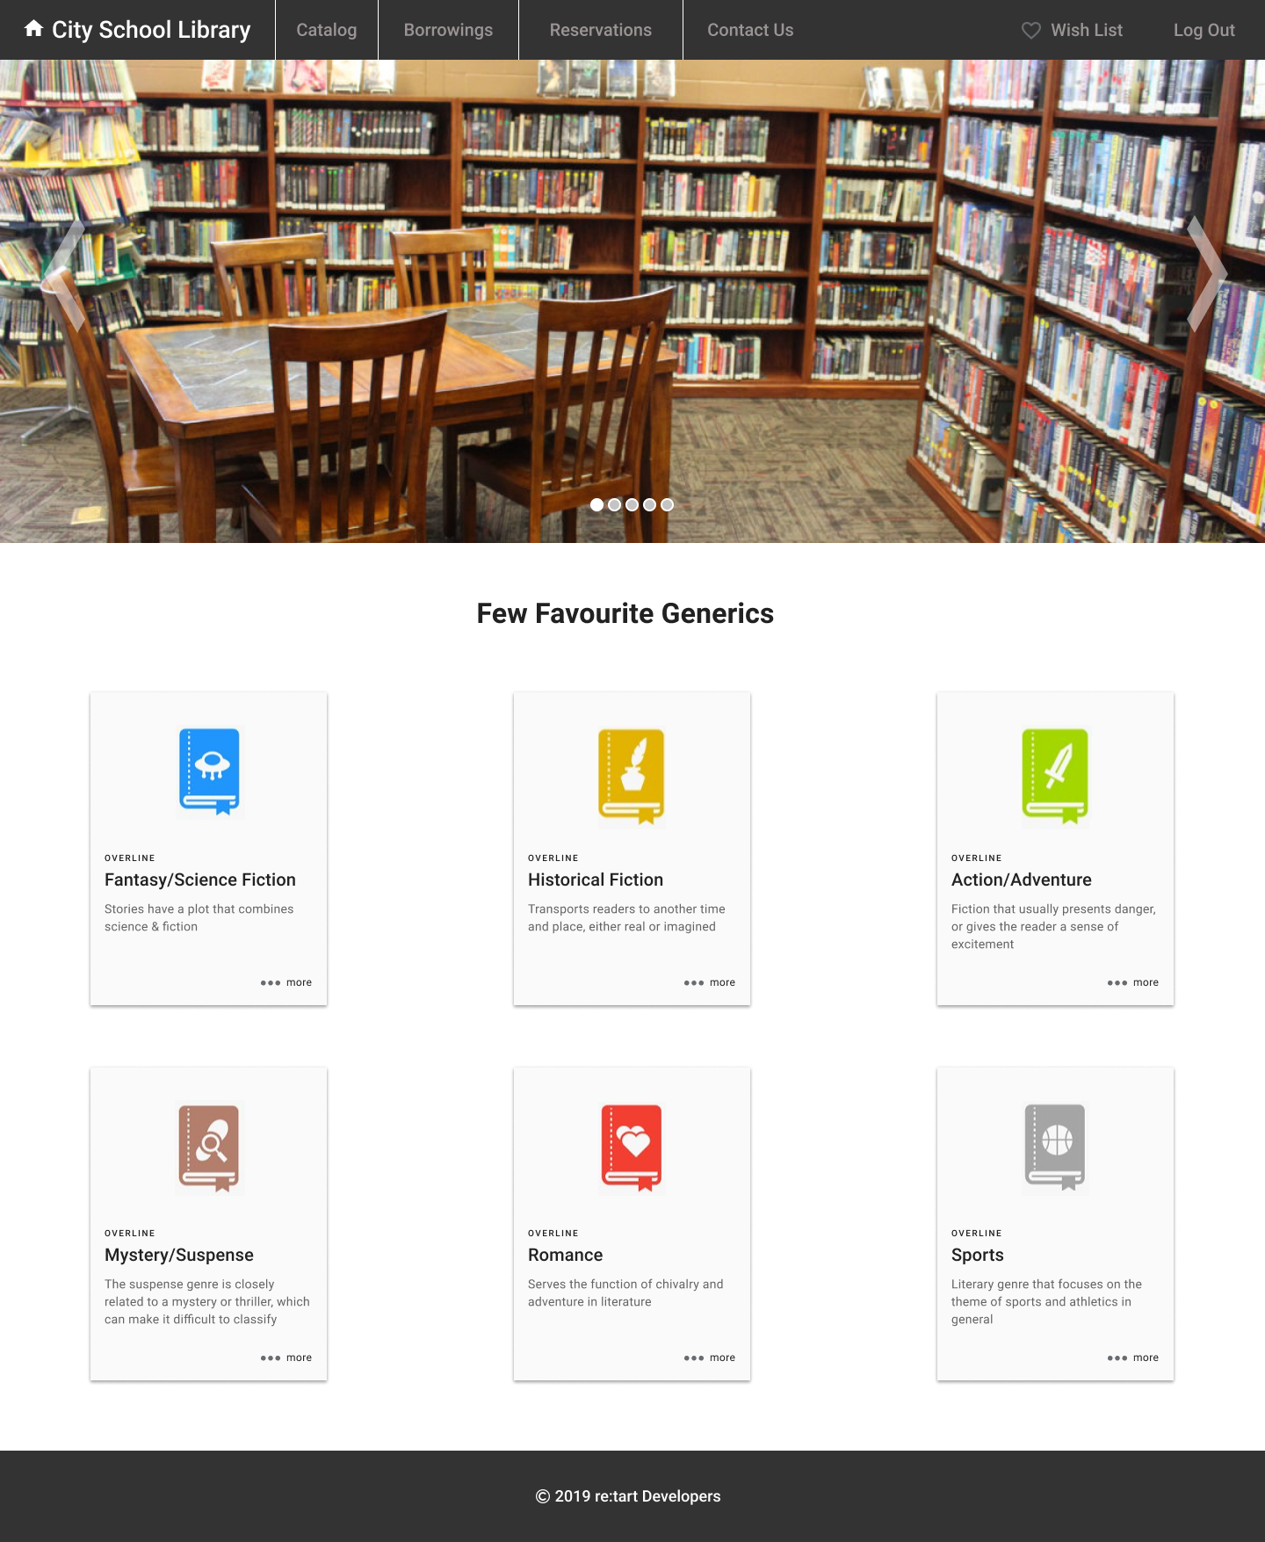

Figure : Home page of student UI

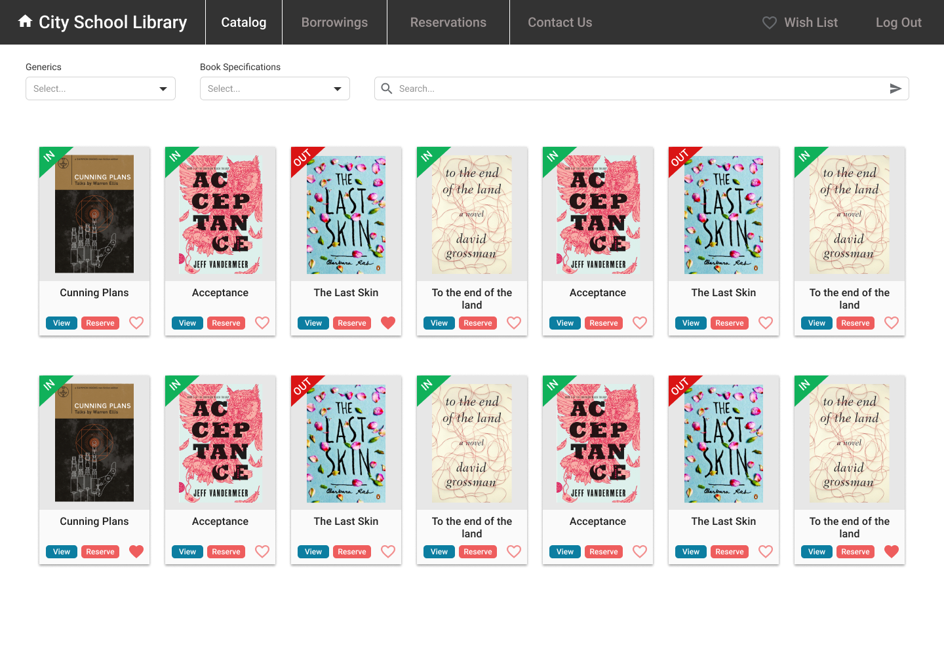

Figure : Library catalog page for view and search all books

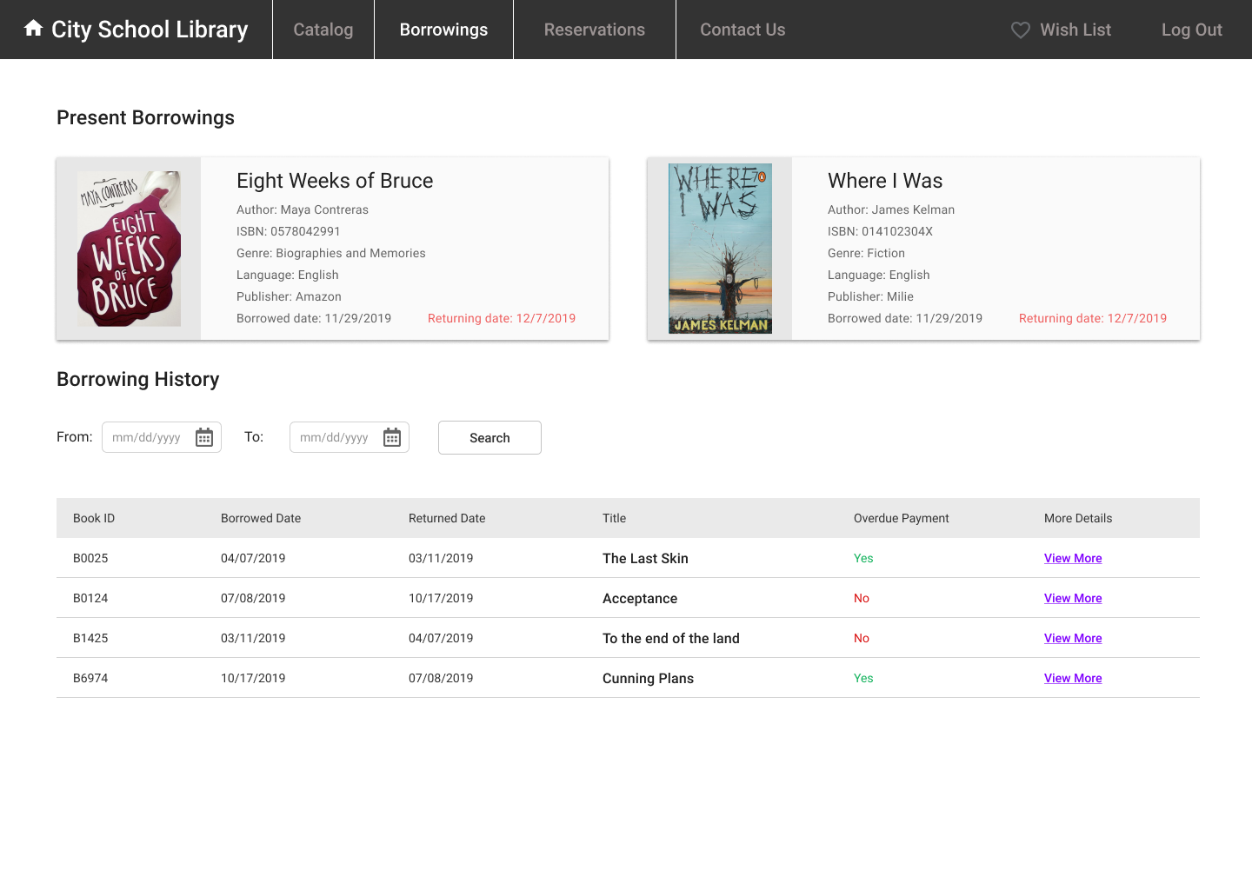

Figure : Borrowing page for see current borrowings and history

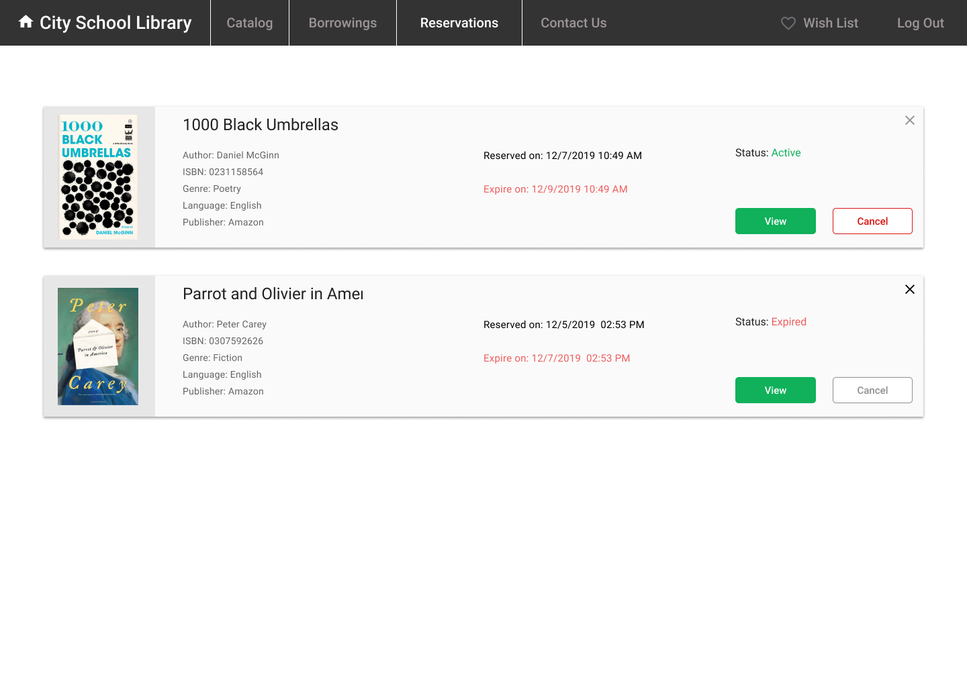

Figure : Student’s reservation page

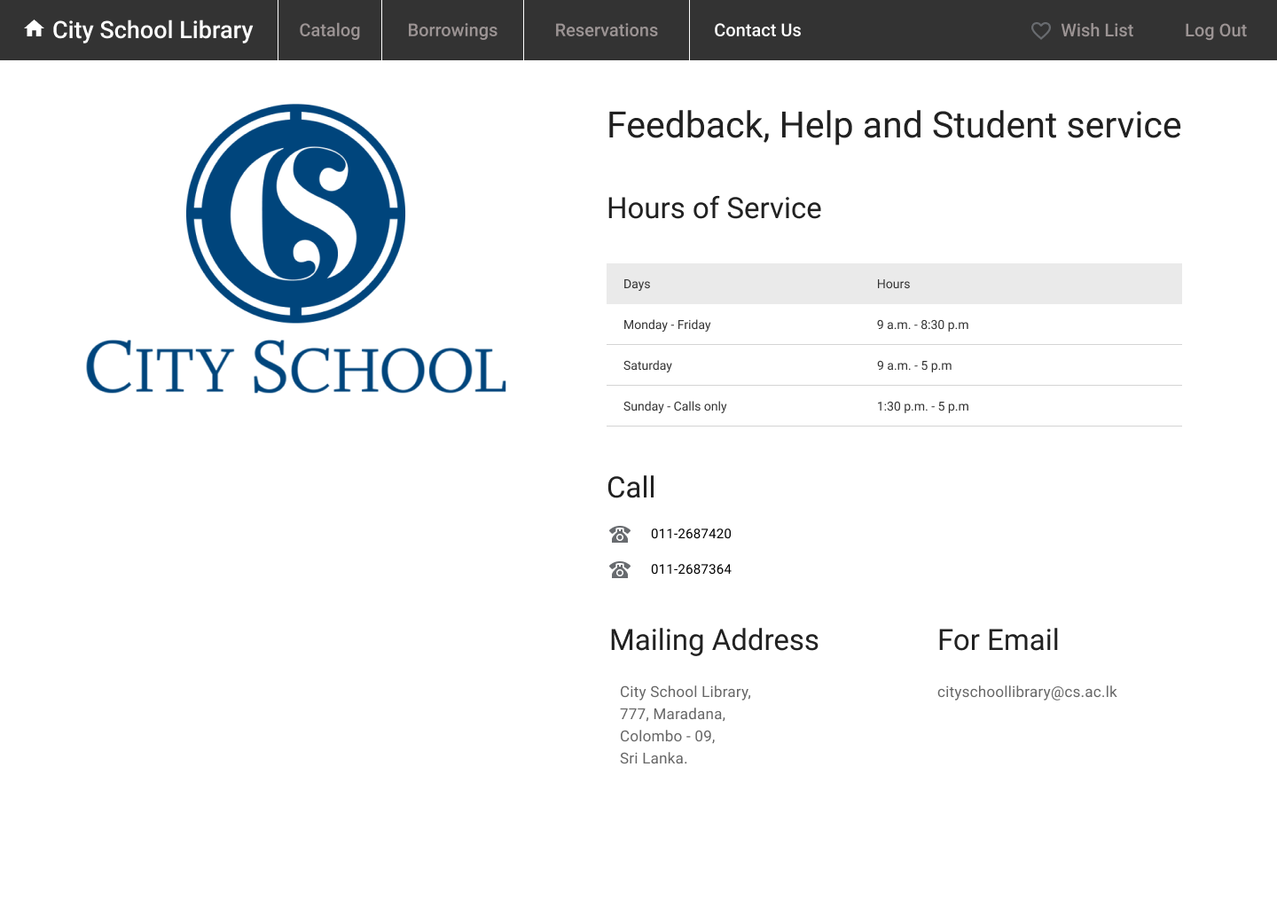

Figure : Library contact details page

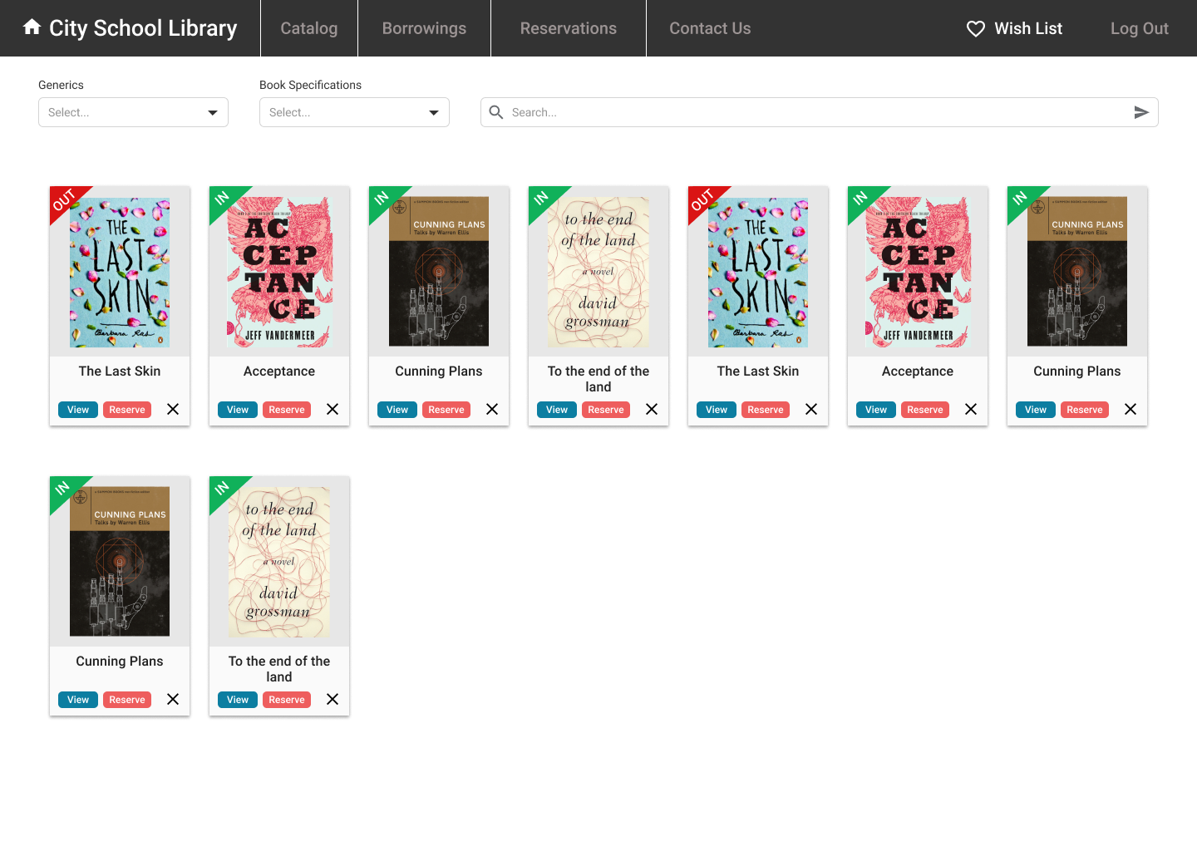

Figure : Student’s wish list page

**Librarian’s Sample UI**

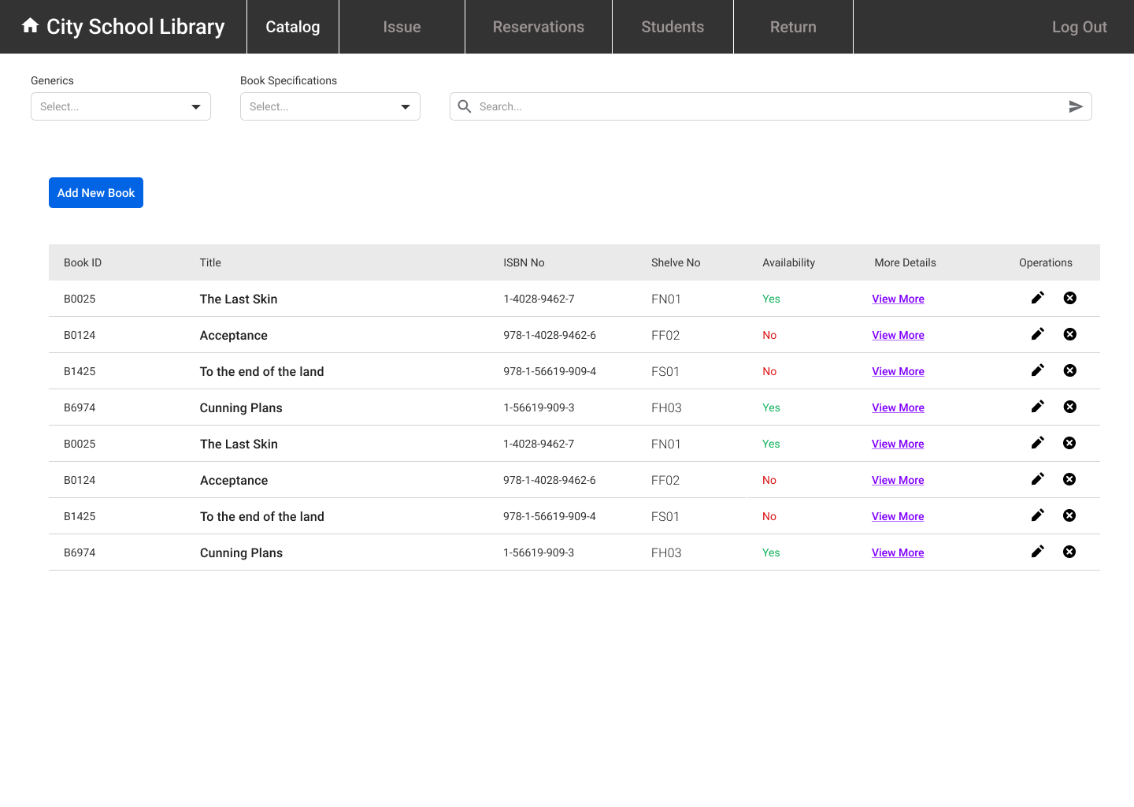

Figure : Librarian’s catalog page for manage books

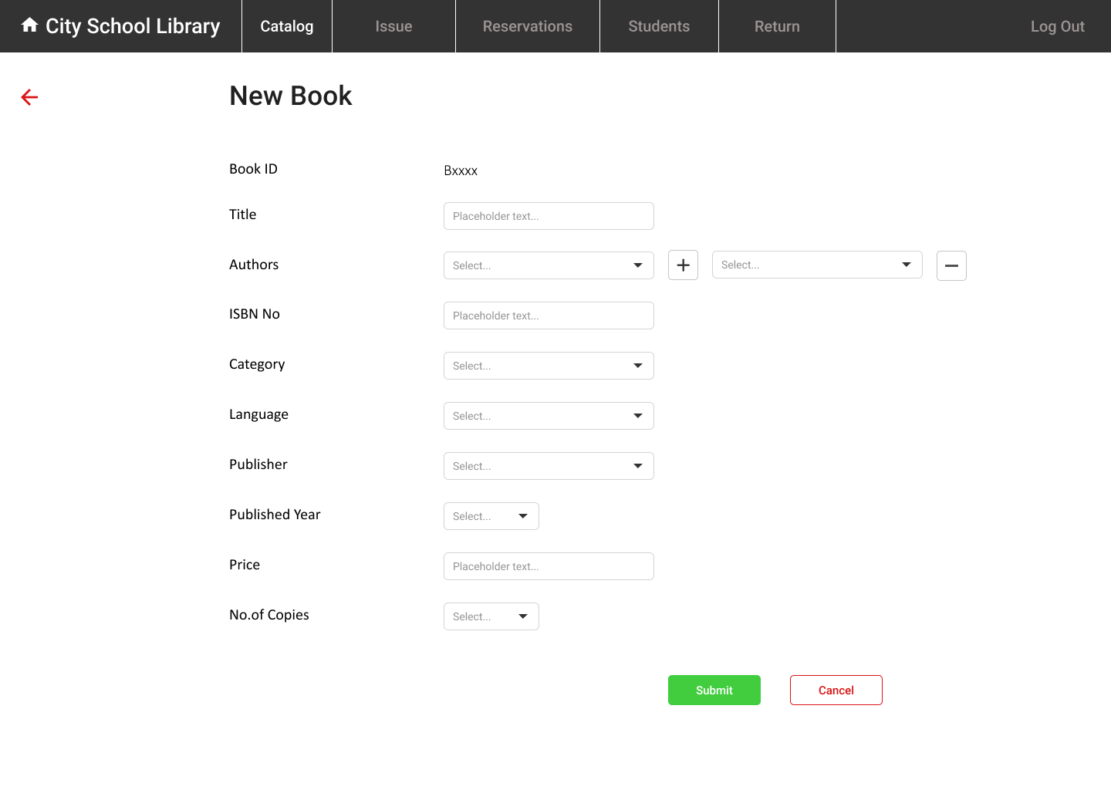

Figure : Insert a new book page

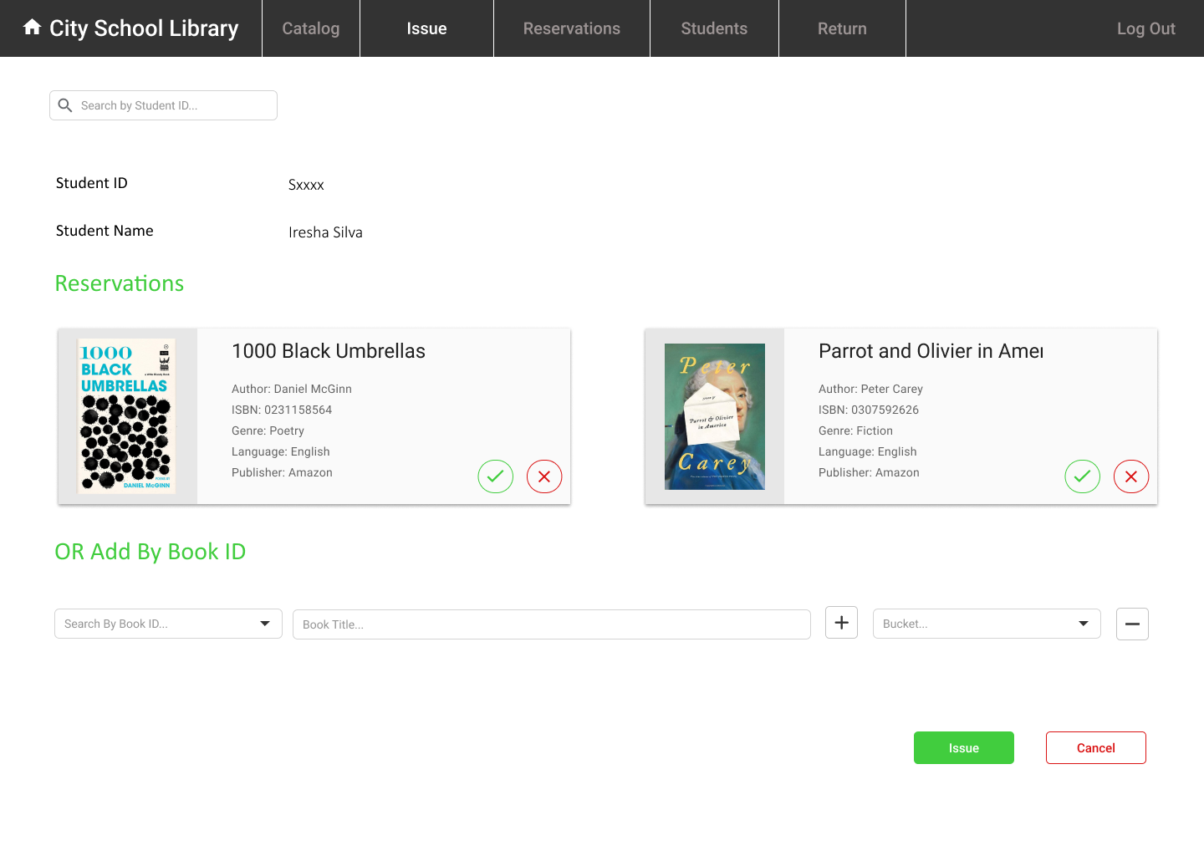

Figure : Librarian’s view when issuing books

Figure : Librarian’s view for all reservations of students

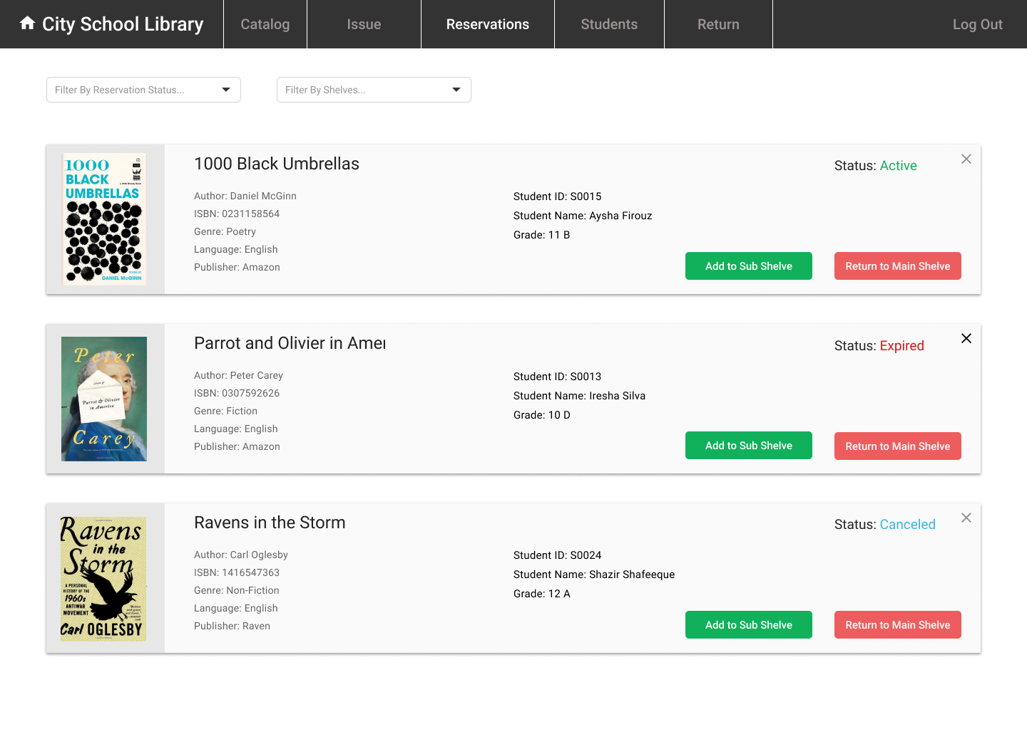

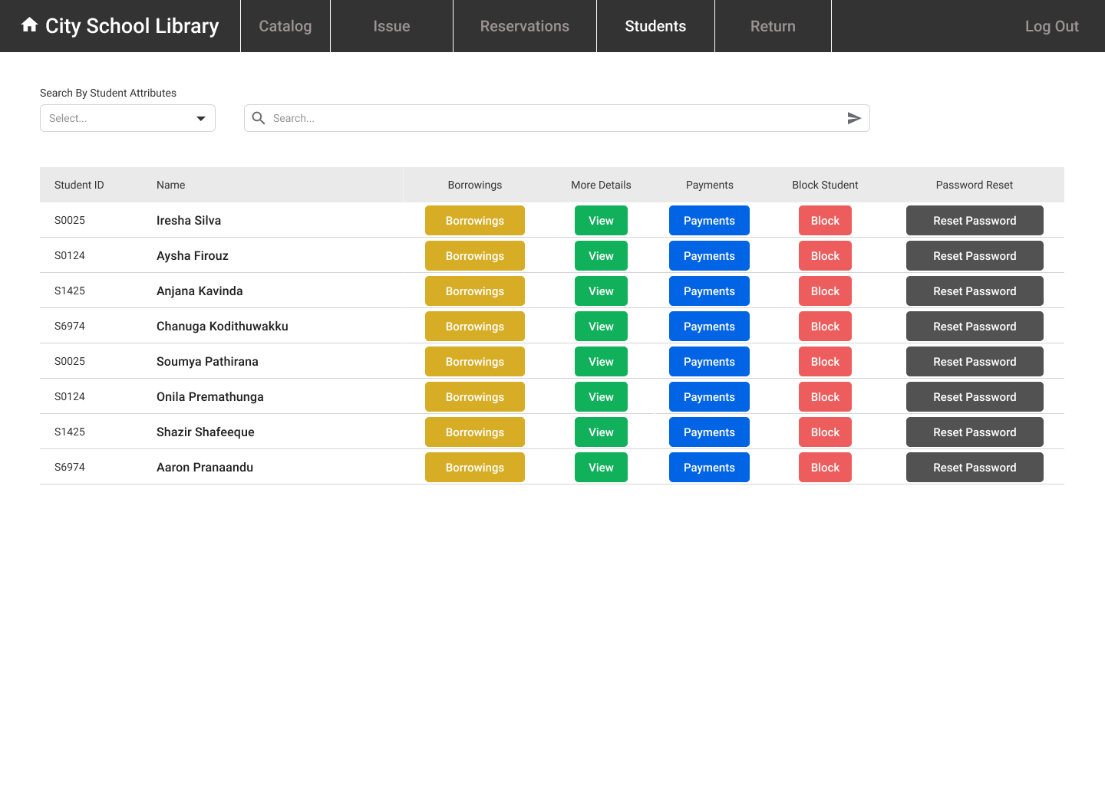

Figure : Librarian’s page for manage students

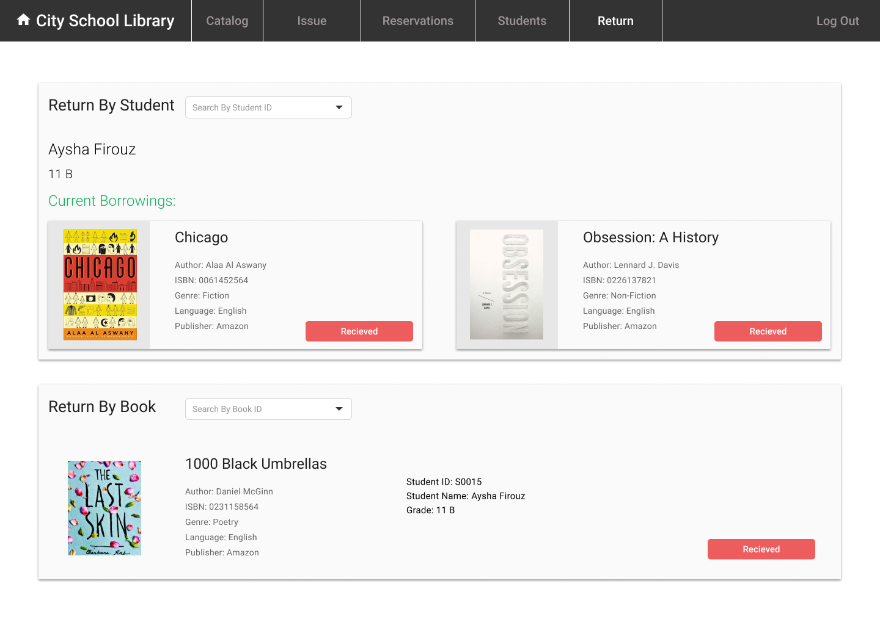

Figure : Librarian’s view when returning books

## Database relationship (ER) diagram

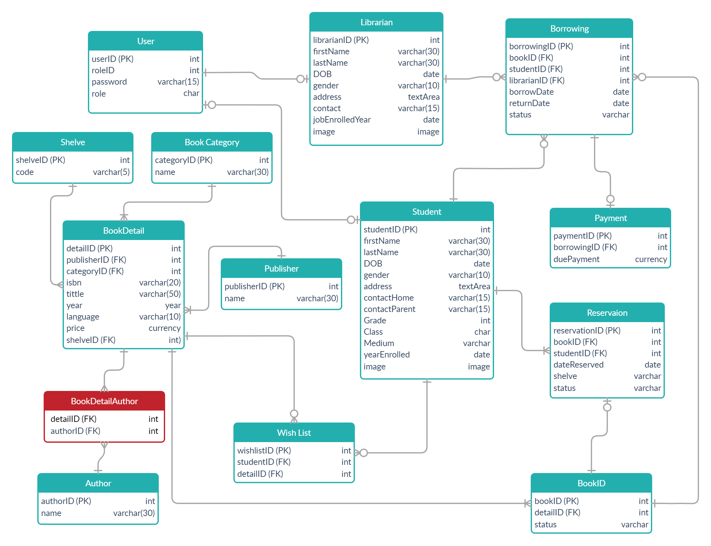

Figure : Entity-Relationship diagram of Library Management System

## Business logic

## Final screenshots